Sennheiser HD 200 PRO: Professional Sound – At Home and in the Studio

Anaheim/Wedemark, 19 January 2017 – At NAMM in Anaheim, California, Sennheiser is introducing the new HD 200 PRO studio headphones. Whether you are an aspiring musician, experienced content creator or ambitious producer, the audio specialist’s new all-purpose headphones offer an ideal entry point into the world of home recording. The new headphones are also the perfect partner for enjoying music with excellent sound quality.

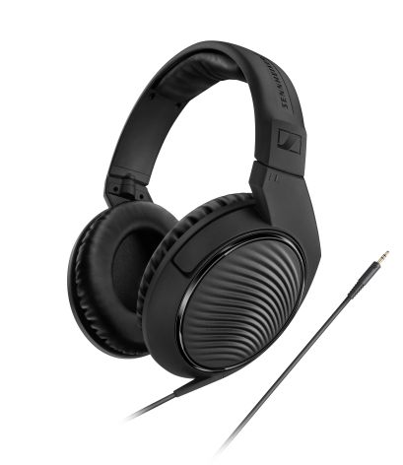

The closed HD 200 PRO headphones have been developed for home recording and production, offering users an accessible entry point with all the benefits of Sennheiser’s characteristic sound performance. Based on Sennheiser’s successful HD 400 series, the HD 200 PRO is tailor-made for monitoring use. Thanks to its accurate sound image, users can mix even the finest nuances of sound when working in their home studios.

“The HD 200 PRO headphones offer a strong, precise audio reproduction for every monitoring application and every budget,” explains Jannik Schentek, Portfolio Manager Live Performance and Music at Sennheiser. “In developing the HD 200 PRO, we focused on optimizing its excellent sound properties for work in home studios, while at the same time giving the user the opportunity to also really enjoy listening to the music they love.”

Freedom from outside interference

The HD 200 PRO is the ideal solution when recording groups, smaller bands or live sessions. The circumaural headphones shield the wearer from outside noise, enabling total concentration on the recorded sound.

Maximum comfort for long recording sessions

With its comfortable ergonomic design, the HD 200 PRO offers excellent wearing comfort even over long recording sessions: The leatherette ear pads mould to the wearer’s head, the headband is comfortably taut and the earphones’ weight is optimized for long sessions.

The HD 200 PRO is fitted with powerful Sennheiser drivers with an impedance of 32 ohms. The headphones come equipped with a 2 m long cable with a straight 3.5 mm headphone jack and a 6.3 mm adapter.

# Technical Data

Ear coupling: around-Ear (circumaural)

Frequency response: 20-20,000 Hz

Impedance: 32 ohms

Sound pressure level (SPL): 108 dB

Jack plug: 3.5 mm (straight), adapter to 6.3 mm

Cable length: 2 m

Load rating: 500 mW

Total harmonic distortion: <0.1 percent

Weight w/o cable: 184 g

Image caption

Image 1 (HD 200 PRO): Sennheiser’s new HD 200 PRO monitoring headphones offer professional studio sound as well as an enjoyable listening experience

About Sennheiser

Audio specialist Sennheiser is one of the world’s leading manufacturers of headphones, microphones and wireless transmission systems. Based in Wedemark near Hanover, Germany, Sennheiser operates its own production facilities in Germany, Ireland and the USA and is active in more than 50 countries. With 19 sales subsidiaries and long-established trading partners, the company supplies innovative products and cutting-edge audio solutions that are optimally tailored to its customers’ needs. Sennheiser is a family-owned company that was founded in 1945 and which today has 2,750 employees around the world that share a passion for audio technology. Since 2013, Sennheiser has been managed by Daniel Sennheiser and Dr. Andreas Sennheiser, the third generation of the family to run the company. In 2015, the Sennheiser Group had sales totaling €682 million. [www.sennheiser.com](http://www.sennheiser.com)

# Press contacts:

|  |  |
| --- | --- |
| USA and Canada Jeff Touzeau  Public Relations  Hummingbird Media, Inc.  (914) 602-2913  jeff@hummingbirdmedia.com | International Sennheiser electronic GmbH & Co. KG  Stephanie Schmidt  PR Manager Professional Systems  Audio Recording • Broadcast & Media •  Live Performance & Music  Am Labor 1 • 30900 Wedemark • Germany  Tel. +49 (5130) 600 – 1275  stephanie.schmidt@sennheiser.com |

Australia & New Zealand

Sennheiser Australia & New Zealand

Heather Reid

PR + Marketing Communications

Phone: +61 (2) 9910 6700

Mobile: +61 448 119 609

Email: heather.reid@sennheiser.com